**I.EVOLUTION OF BANKING TECHNOLOGY IN THE US BANKING SYSTEM**

The evolution of banking technology in the US banking system has been marked by significant advancements over the past several decades.

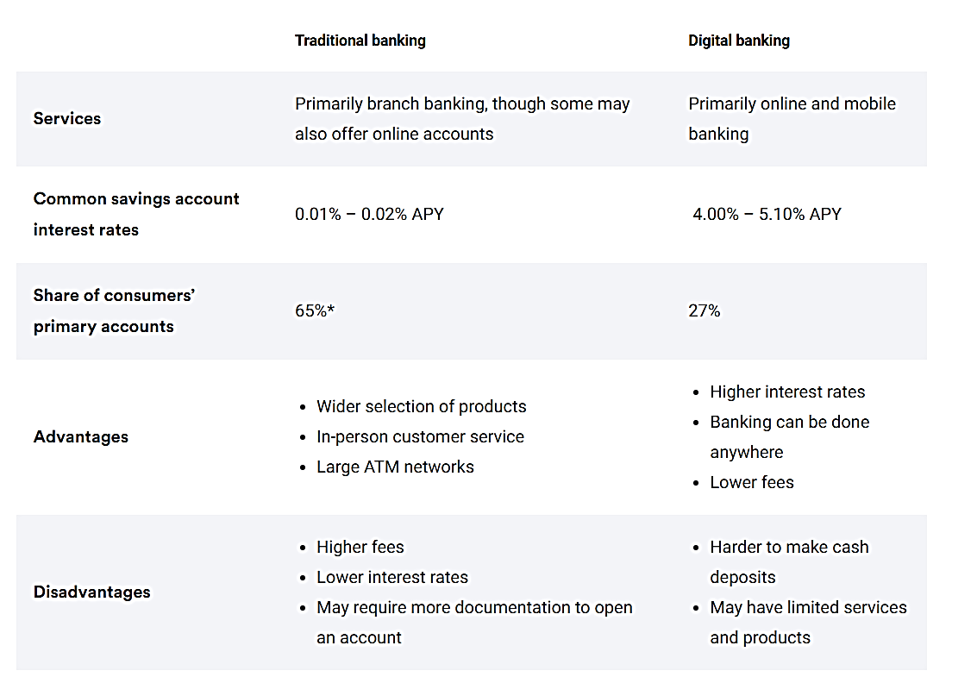

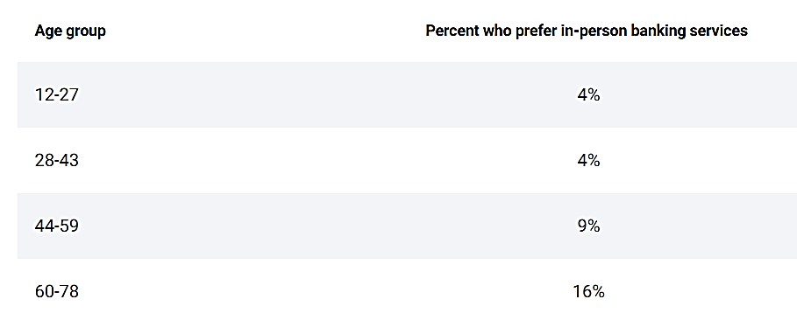

1. **Early Developments (1950s-1960s)**

**Credit Cards:**

The first credit card, Diners Club, was introduced in **1950**, revolutionizing consumer spending habits by allowing for portable payment solutions.

1. **Mainframe Era (1960s-1980s)**

**Computers in Banking:**

The Bank of New South Wales purchased its first computer in 1960 for **£1 million (approximately $26 million today)**, marking the beginning of digital banking.

**ATMs:**

The first ATM was installed in 1967 by **Barclays Bank**, enabling customers to access their money outside of bank hours.

1. **Online Banking and Mobile Banking (1980s-2000s)**

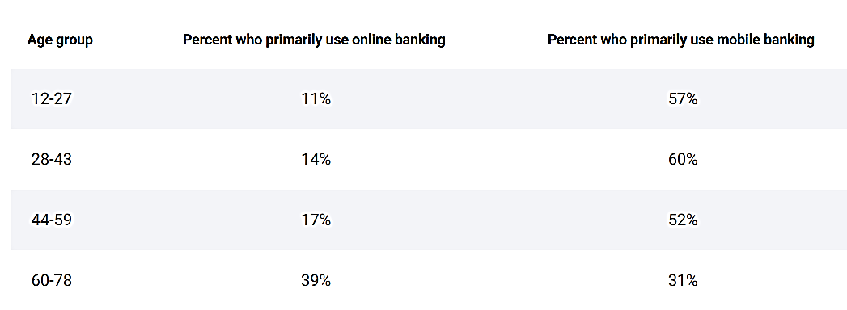

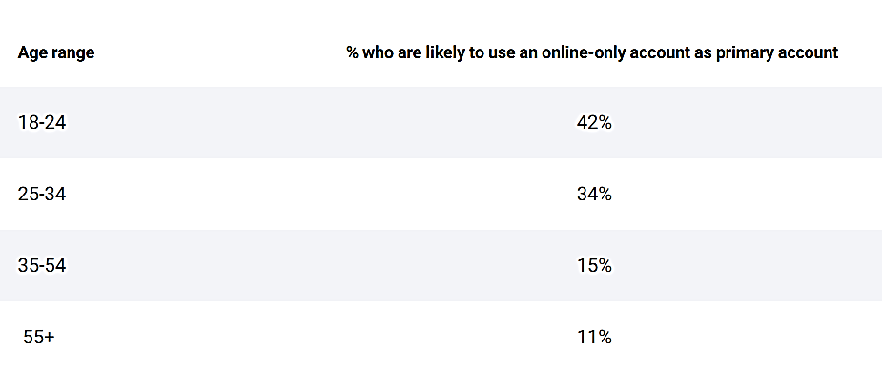

**Online Banking:**

The term "online" became popular in the 1980s, referring to the use of terminals, keyboards, and TVs to access banking systems over phone lines. This led to,

* lower transaction costs
* easier integration of services
* targeted marketing capabilities.

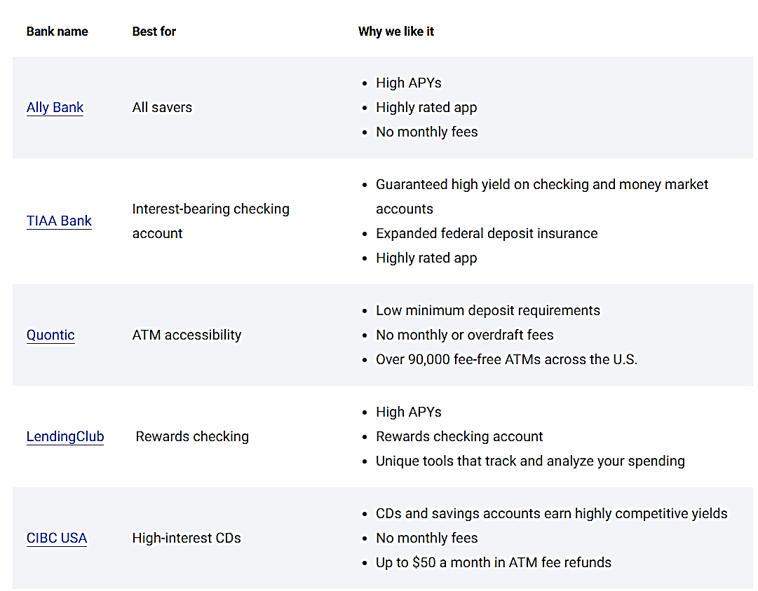

**Mobile Banking:**

The advent of wireless technology and smartphones in the early 2000s enabled mobile banking, allowing customers to manage their financial lives from anywhere and at any time.

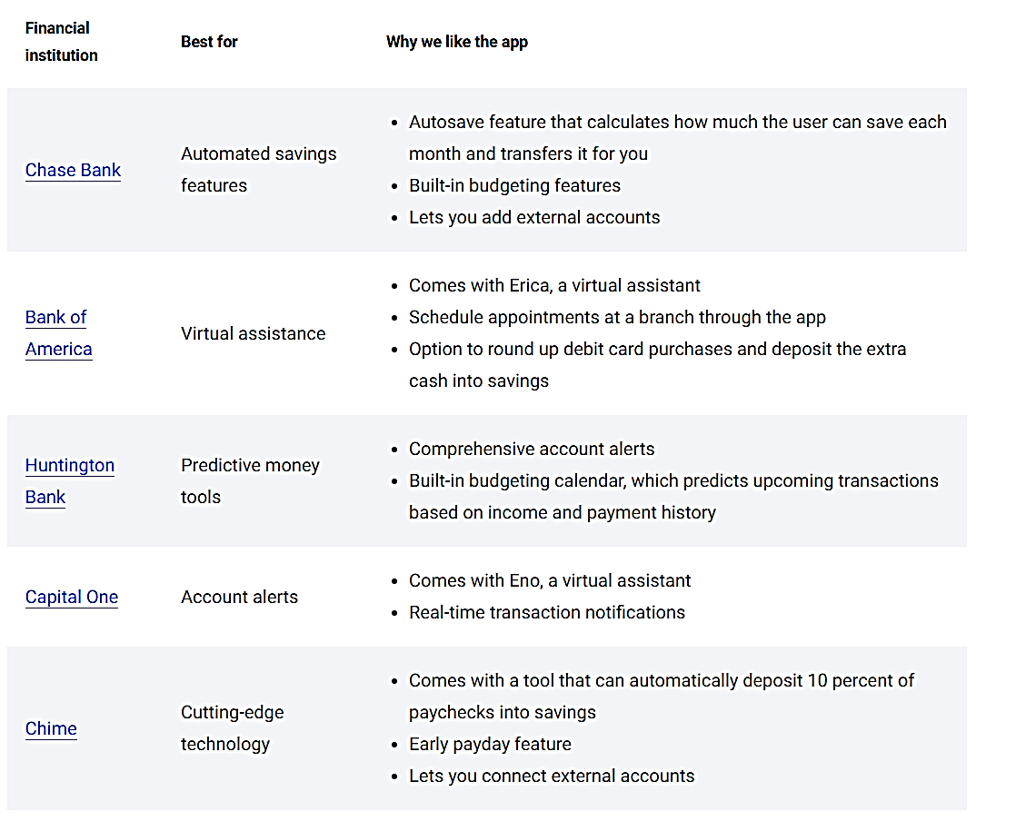

1. **Recent Trends (2010s-Present)**

**Digital Banking Adoption:**

A 2021 J.D. Power survey found that 41% of customers have gone digital-only, with many banks offering innovative digital tools, such as AI-powered budgeting and new payment methods.

**Cloud Migration:**

Banks are increasingly moving to the cloud, with concerns about security risks and adapting risk capabilities to address cloud-specific risks.

**Automation and AI:**

Automation is being used to better understand and manage risks in real time, and AI is being applied to audits, financial crime monitoring, and compliance activities.

**Statistical Data**

**Branch Closures:** The number of bank branches in the US has declined significantly, with over 2,500 branches closed in 2023 alone.

**Digital Banking Adoption:** Most Americans have used digital banking services in the past year, and more banks are offering new digital tools.

**Some of the examples**

**First Direct:** Introduced Telephone banking in the 1980s and Internet banking at the end of the 1990s, paving the way for digital banking.

**PayPal:** Launched in the late 1990s, PayPal enabled wireless transfers, leading to a proliferation of similar services like Venmo and Zelle.

These developments demonstrate the rapid evolution of banking technology in the US, driven by advancements in computing, mobile devices, and cloud technology.

**II. BANKING SYSTEM RESILIENCE DURING ECONOMIC CRISES**

The resilience of the U.S. banking system during economic crises is a critical aspect of its stability and reliability. This resilience is tested during significant financial downturns, such as the 2008 financial crisis and the COVID-19 pandemic.

**The 2008 Financial Crisis**

The 2008 financial crisis, one of the most severe economic downturns since the Great Depression, was precipitated by the collapse of the housing bubble in the United States. This collapse led to a liquidity crisis, causing major financial institutions to fail or require government bailouts.

**Impact on Banks**

**Failures and Bailouts:** The crisis led to the failure of major financial institutions such as Lehman Brothers, which declared bankruptcy in September 2008. Other large banks, including Merrill Lynch, AIG, and Citigroup, faced severe distress and required government intervention.

**Government Intervention:** To stabilize the banking sector, the U.S. government implemented the Troubled Asset Relief Program (TARP), which authorized the Treasury to purchase up to **$700 billion** in troubled assets from banks.

**Resilience Measures**

**Capital Adequacy:** In response to the crisis, banks were required to bolster their capital reserves. The Federal Reserve implemented stress tests to ensure that banks had sufficient capital to absorb potential losses from future economic shocks. These stress tests evaluated banks' ability to maintain capital above minimum requirements under adverse economic conditions.

**Regulatory Reforms:** The Dodd-Frank Wall Street Reform and Consumer Protection Act was enacted in 2010 to overhaul financial regulation and prevent future crises. Key provisions included the establishment of the Consumer Financial Protection Bureau (CFPB), the Volcker Rule (restricting proprietary trading by banks), and enhanced oversight of financial institutions deemed systemically important.

**Statistical Data**

**Bank Failures:** From 2008 to 2010, over 300 banks failed in the U.S., a significant increase compared to the average of about 10 per year in the preceding decade. This surge in failures underscored the severity of the crisis and the vulnerabilities within the banking sector.

**Capital Ratios:** The Tier 1 capital ratio, a key measure of a bank’s financial strength, increased from 7.5% in 2008 to over 12% by 2013. This improvement reflected the concerted efforts by banks and regulators to enhance capital buffers and ensure greater resilience against future shocks.

**The COVID-19 Pandemic**

The COVID-19 pandemic in 2020 led to a sudden and severe economic contraction, causing widespread business closures, surging unemployment, and unprecedented economic uncertainty.

**Impact on Banks**

**Loan Defaults:** Banks faced unprecedented levels of loan defaults as businesses closed and individuals lost their jobs. The drop-in economic activity severely affected borrowers’ ability to repay loans, leading to increased non-performing loans.

**Liquidity Demand:** There was a heightened demand for liquidity from businesses and individuals seeking to shore up cash reserves amidst economic uncertainty. Banks experienced a significant increase in withdrawal requests and loan applications.

**Resilience Measures**

**Federal Reserve Interventions:** To stabilize the economy, the Federal Reserve cut interest rates to near zero and introduced quantitative easing programs, purchasing large quantities of government securities to inject liquidity into the financial system.

**Paycheck Protection Program (PPP):** Banks played a crucial role in the implementation of the PPP, a government program designed to provide forgivable loans to small businesses to cover payroll and other essential expenses. This initiative helped mitigate the economic impact on businesses and supported continued employment.

**Capital and Liquidity Buffers:** Thanks to regulatory reforms post-2008, banks entered the pandemic with stronger capital positions and liquidity buffers. These measures helped banks absorb the initial shocks and continue to function effectively.

**Statistical Data**

**Loan Defaults:** Loan delinquency rates for commercial banks peaked at around 2.4% in mid-2020, compared to a peak of over 6% during the 2008 crisis. This lower peak indicates the relative effectiveness of resilience measures implemented after the 2008 crisis.

**Stress Tests:** The Federal Reserve's stress tests in 2020 showed that major banks had sufficient capital to withstand a severe economic downturn. These stress tests assessed the potential impact of the pandemic on banks' capital positions and demonstrated their preparedness to manage significant losses.

**Examples of Bank Responses and Adjustments**

**JP Morgan Chase**

**2008 Crisis Response:** JP Morgan acquired Bear Stearns in March 2008 and Washington Mutual in September 2008, significantly expanding its market presence and customer base. The bank also raised capital through stock sales and participated in TARP, receiving $25 billion in government support.

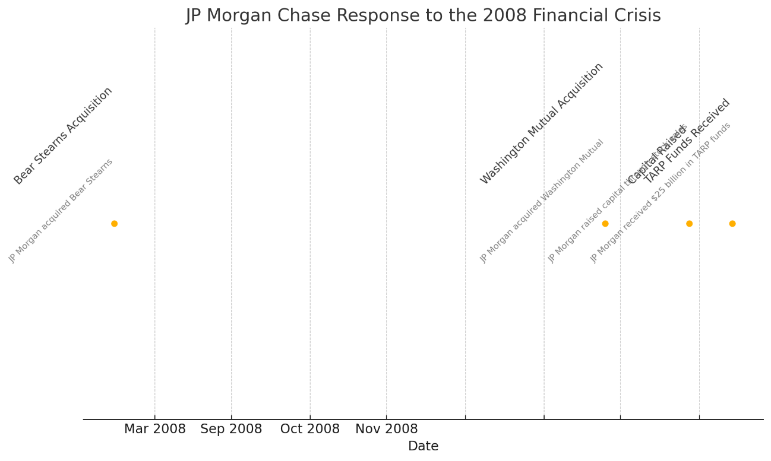

* **March 16, 2008:** Acquisition of Bear Stearns.
* **September 25, 2008:** Acquisition of Washington Mutual.
* **October 28, 2008:** Raising capital through stock sales.
* **November 14, 2008:** Receiving $25 billion in TARP funds.

**COVID-19 Response:** JP Morgan set aside over $20 billion in reserves to cover potential loan losses. The bank also played a pivotal role in facilitating billions in PPP loans, providing critical support to small businesses affected by the pandemic.

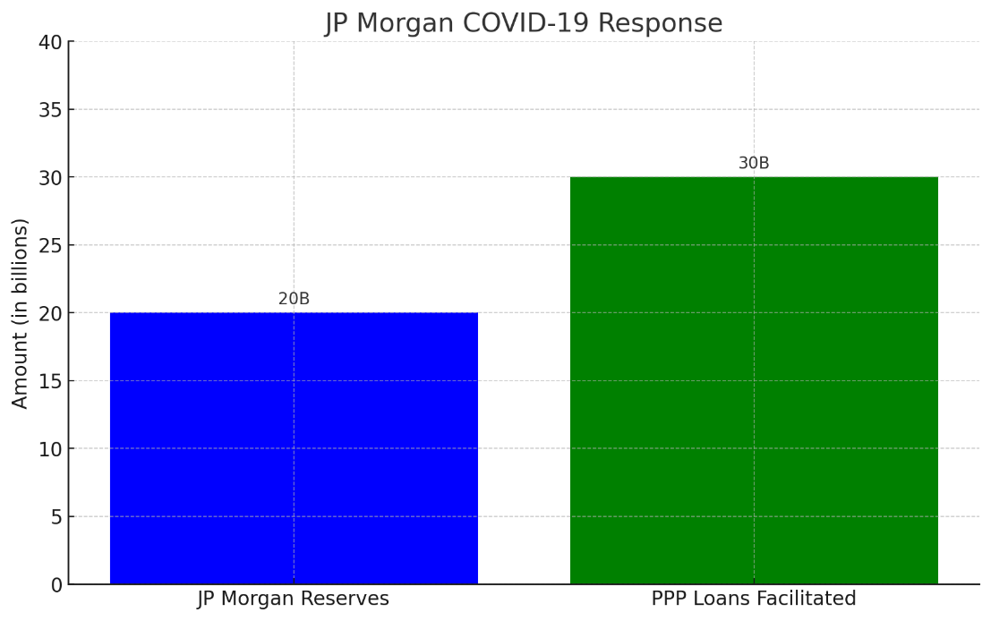

* **$20 billion** was set aside in reserves to cover potential loan losses.
* **$30 billion** facilitated in PPP loans to support small businesses affected by the pandemic.

**Bank of America**

**2008 Crisis Response:** Bank of America acquired Merrill Lynch in January 2009, enhancing its investment banking capabilities. The acquisition was facilitated by $45 billion in TARP funds, which helped stabilize the bank during the financial crisis.

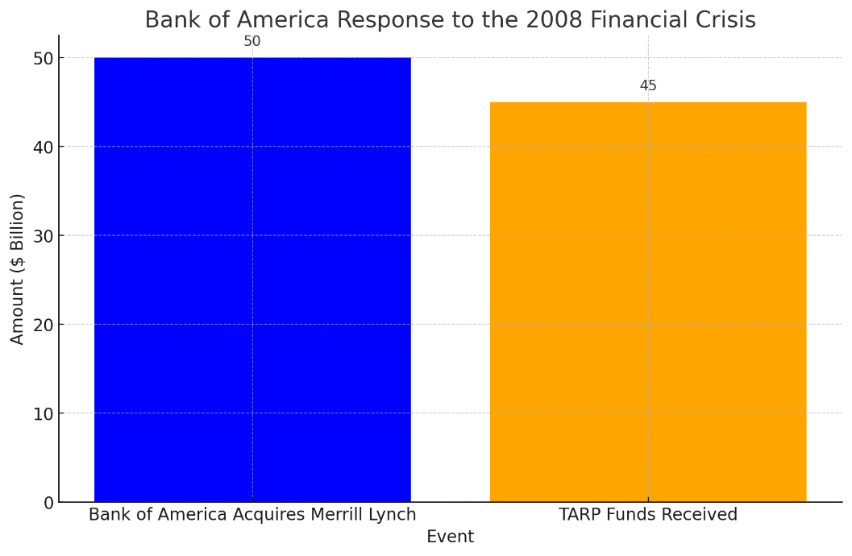

* **Bank of America Acquires Merrill Lynch:** Approximately $50 billion.
* **TARP Funds Received:** $45 billion.

**COVID-19 Response:** Bank of America provided over $25 billion in PPP loans and deferred payments on mortgages and credit cards to support customers facing financial hardship. These measures helped alleviate the economic burden on borrowers and maintained customer relationships during the crisis.

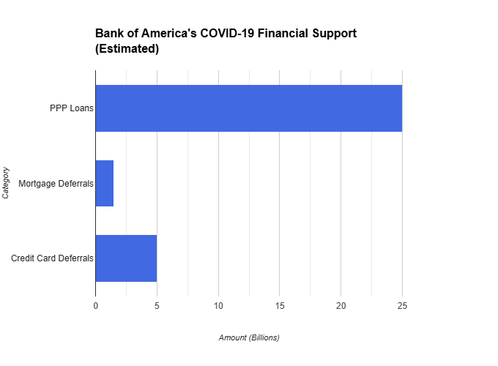

The chart highlights Bank of America's COVID-19 relief efforts. PPP loans dominated at $25 billion, followed by mortgage and credit card deferrals at significantly lower amounts. This targeted approach aimed to support businesses and ease burdens on borrowers facing financial hardship during the pandemic.

The resilience of the U.S. banking system during major economic crises has been demonstrated through a combination of regulatory reforms, government interventions, and prudent risk management practices. The experiences of the 2008 financial crisis and the COVID-19 pandemic highlight the critical importance of robust capital and liquidity buffers, regulatory oversight, and the ability of banks to adapt to changing economic conditions.